**AI Assisted Coding**

**Assignment-01**

**Name :M.Anjali**

**Hallticket:2303A51025**

**Batch-01**

**Task:01**

* + **A working Python program generated with Copilot assistance**
* #Assingment-01
* #Date:12/01/2026
* #write a code to print the factorial of the given number without using the function
* num = int(input("Enter a positive integer to find its factorial: "))
* if num < 0:
* print("Please enter a positive integer")
* else:
* factorial = 1
* for i in range(1, num + 1):
* factorial *= i
* print(f"The factorial of {num} is {factorial}")
  + **Screenshot(s) showing:**

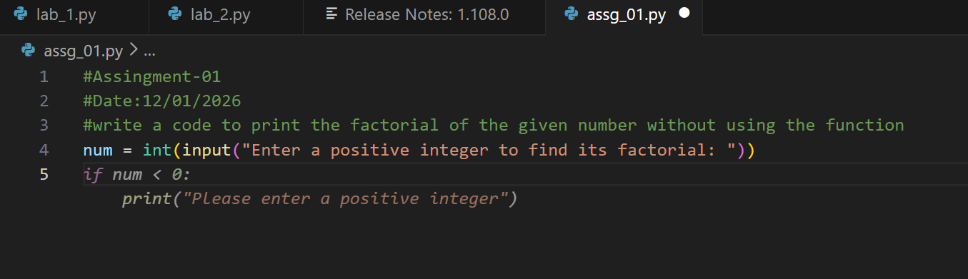

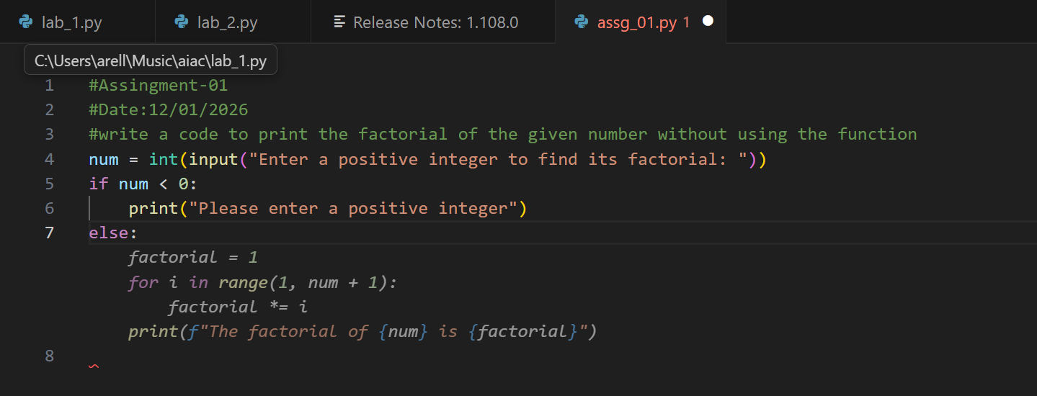

* + **Sample input/output screenshots**

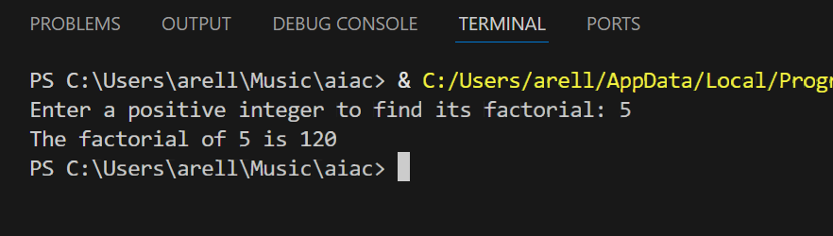

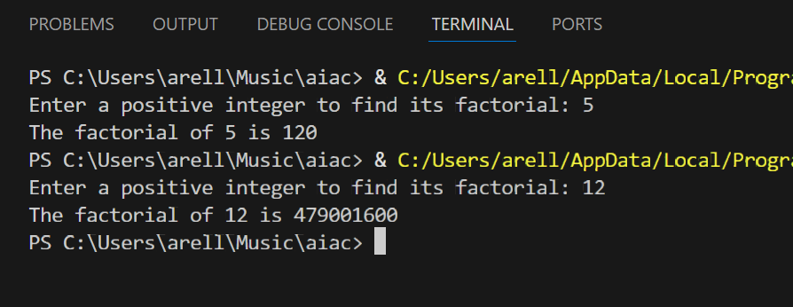

* + **Brief reflection (5–6 lines):**
* GitHub Copilot was used to generate the logic quickly without putting much thought into the program structure. It advocated a fresh and clean approach to code and made it readable without having functions in use. Following its suggestions, I reduced the need for me to memorize exact syntax, freeing my mind to focus on the core logic. Copilot also helped me write simple and efficient code in a neat way. Overall, it was faster to develop, less stressful and better in terms of clarity.
  + **How helpful was Copilot for a beginner?**

->copilot is very useful for beginners because it provides instant code suggestion when the user is stuck in middle. It will help beginner by suggesting the code so that user can understand the code and memorized and it makes learning programming easier and more confident

* + **Did it follow best practices automatically?**

->Yes it follows best practices automatically for user by writing the code itself copilot will guess the next lines by that user can also more confident and user also get to know what next should be .It automatically best practices

**Task-02**

* + **Screenshot(s) showing:**

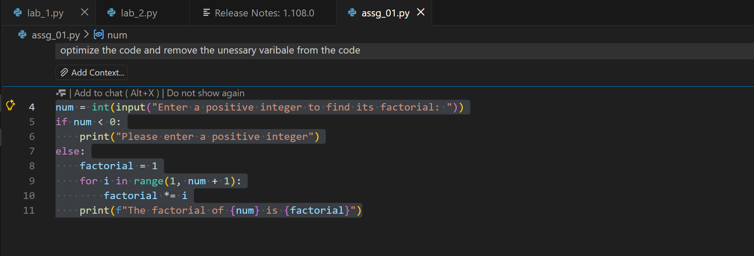

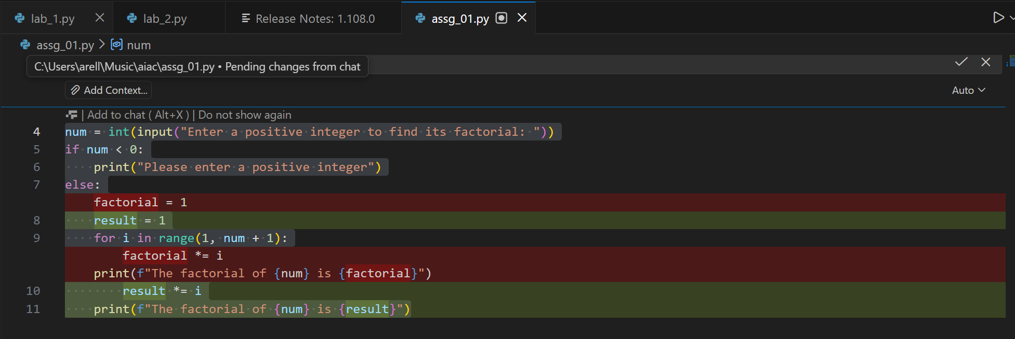

**code**

|  |
| --- |
| #Assingment-01 #Date:12/01/2026 #write a code to print the factorial of the given number without using the function num = int(input("Enter a positive integer to find its factorial: ")) if num < 0:  print("Please enter a positive integer") else:  result = 1  for i in range(1, num + 1):  result *= i  print(f"The factorial of {num} is {result}") |

**side by side comparition**

|  |  |
| --- | --- |
|  |  |

|  |
| --- |
| n=int(input("Enter a number: ")) result = 1 if n < 0: print("Factorial is not defined for negative numbers") else: for i in range(1, n + 1): result = result * i print("Factorial of", n, "is", result) |

**optimal code**

|  |
| --- |
| n = int(input("Enter a number: ")) if n < 0: print("Factorial is not defined for negative numbers") else: result = 1 for i in range(2, n + 1): result *= i print(f"Factorial of {n} is {result}") |

**task-03**

Modular Design Using AI Assistance (Factorial with Functions)

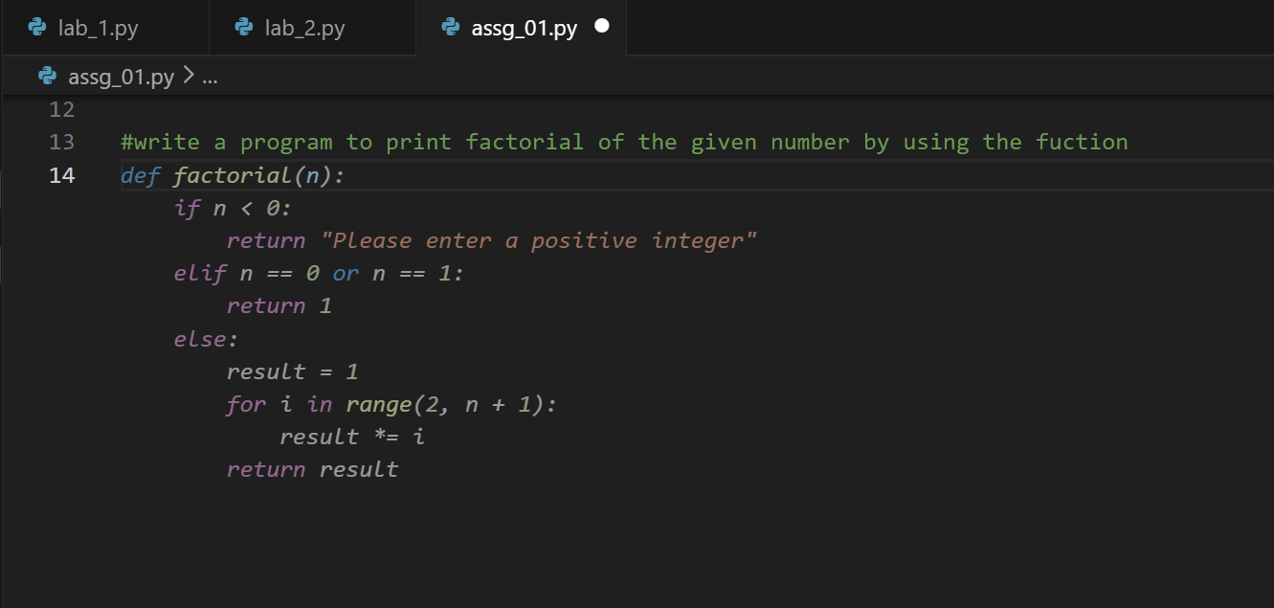

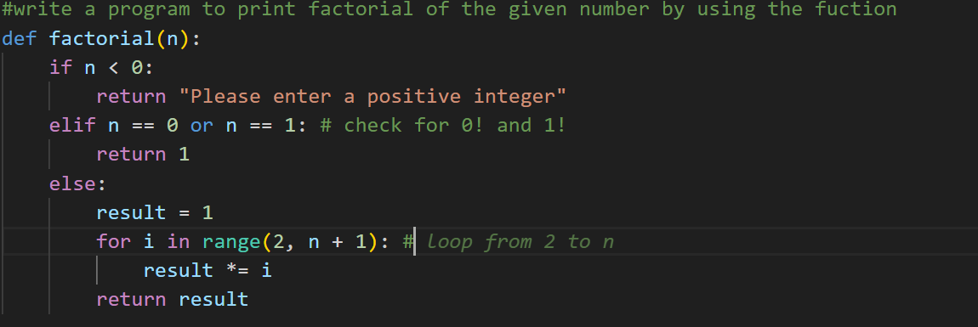

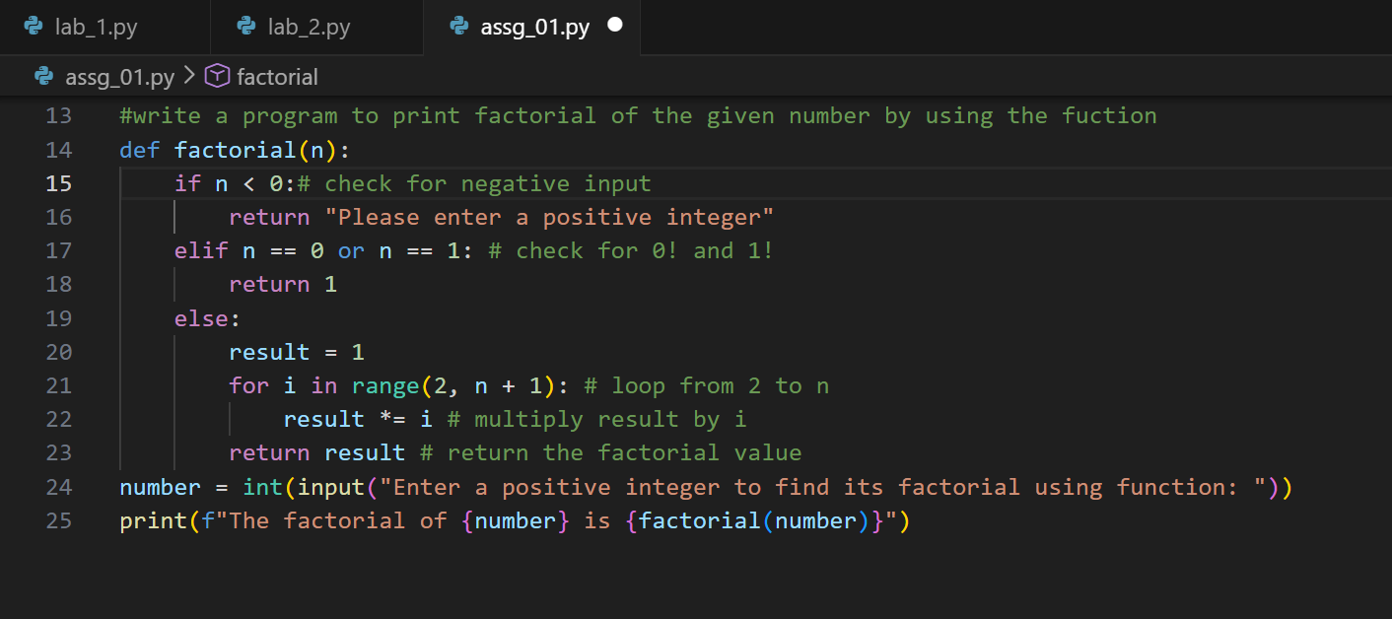

|  |
| --- |
| #write a program to print factorial of the given number by using the fuction def factorial(n):  if n < 0:# check for negative input  return "Please enter a positive integer"  elif n == 0 or n == 1: # check for 0! and 1!  return 1  else:  result = 1  for i in range(2, n + 1): # loop from 2 to n  result *= i # multiply result by i  return result # return the factorial value number = int(input("Enter a positive integer to find its factorial using function: ")) print(f"The factorial of {number} is {factorial(number)}") |

* + **Sample input/output screenshots**

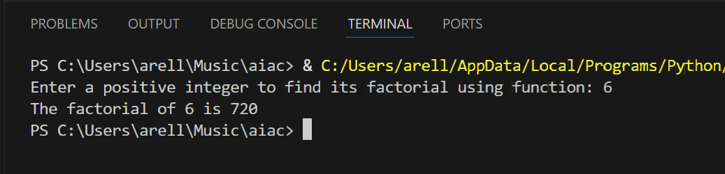

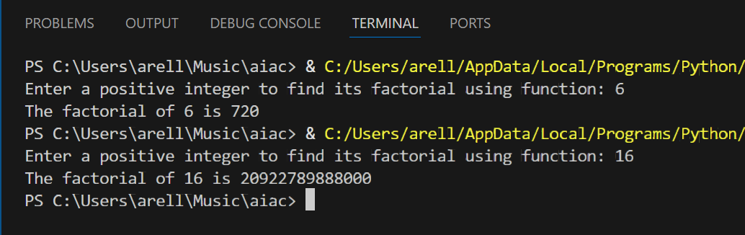

**Short note:**

**How modularity improves reusability.**

* Modularity improves reusability by breaking a program into independent, self-contained parts such as functions or modules. Each module can be reused in different programs or in multiple places within the same program without rewriting code. This reduces duplication and saves development time. Modular code is also easier to test, debug, and maintain because changes in one module do not affect the entire program. Overall, modularity makes software more flexible and scalable..

**Task 4:**

Comparative Analysis – Procedural vs Modular AI Code (With vs Without Functions

**🔹 Comparative Analysis: Procedural vs Modular AI Code**

|  |  |  |
| --- | --- | --- |
| **Criteria** | **Procedural Code (Without Functions)** | **Modular Code (With Functions)** |
| **Logic Clarity** | The logic is written in a single block, which is easy to understand for small programs but becomes difficult to follow as the code grows. | The logic is organized inside a function, making the program more structured and easier to understand. |
| **Reusability** | The code cannot be reused easily and must be rewritten if the same logic is needed again. | The function can be reused multiple times across the program or in other programs. |
| **Debugging Ease** | Debugging is harder because the entire code must be checked for errors. | Debugging is easier since errors are confined within the function. |
| **Suitability for Large Projects** | This approach is not suitable for large projects due to poor structure and maintainability. | This approach is suitable for large projects because modular design improves organization and scalability. |
| **AI Dependency Risk** | Since the logic is simple, dependency on AI is minimal. | Over-dependence on AI-generated functions without understanding the logic can introduce risks. |

**Task 5:**

AI-Generated Iterative vs Recursive Thinking

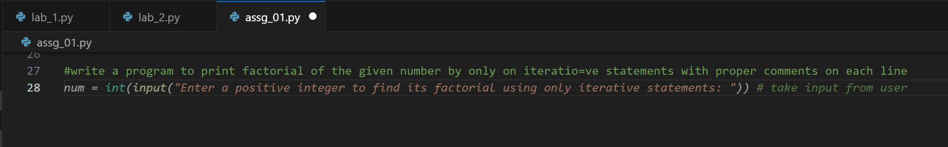

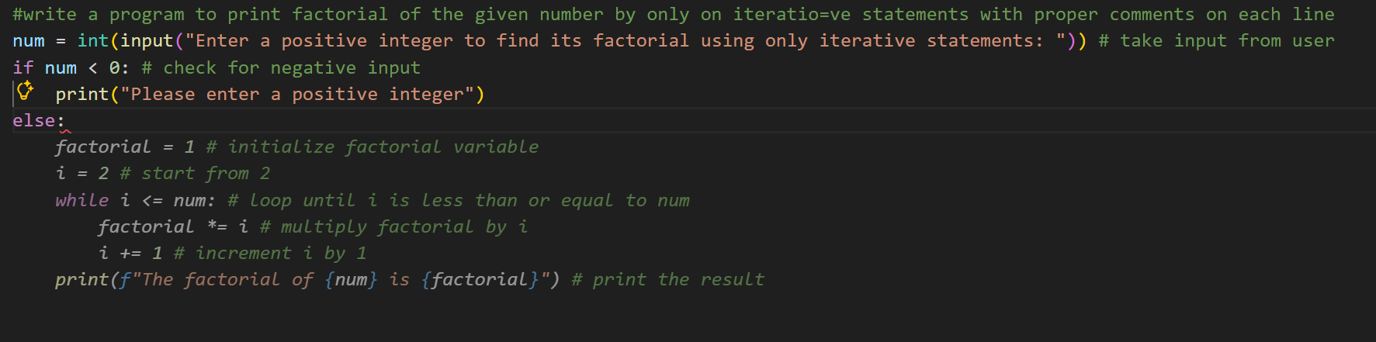

|  |
| --- |
| #write a program to print factorial of the given number by only on iteratio=ve statements with proper comments on each line  num = int(input("Enter a positive integer to find its factorial using only iterative statements: ")) # take input from user if num < 0: # check for negative input  print("Please enter a positive integer") else: # if input is valid  factorial = 1 # initialize factorial variable  i = 2 # start from 2  iteration_count = 0 # initialize iteration counter  while i <= num: # loop until i is less than or equal to num  factorial *= i # multiply factorial by i  i += 1 # increment i by 1  iteration_count += 1 # increment iteration counter  print(f"The factorial of {num} is {factorial}") # print the result  print(f"Number of iterations: {iteration_count}") # print iteration count |

**outputs**

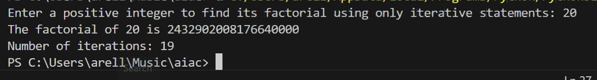



**Using Recursion:**

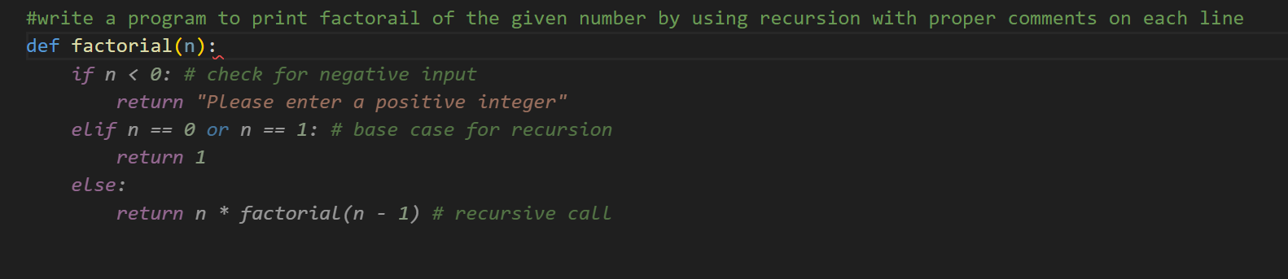

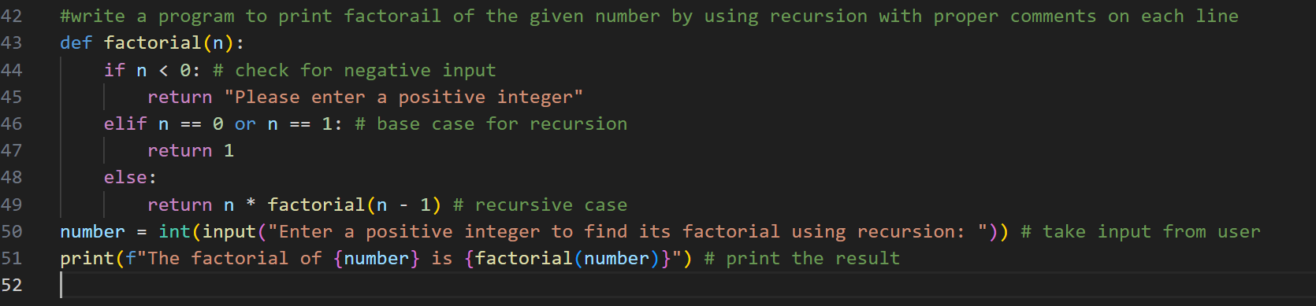

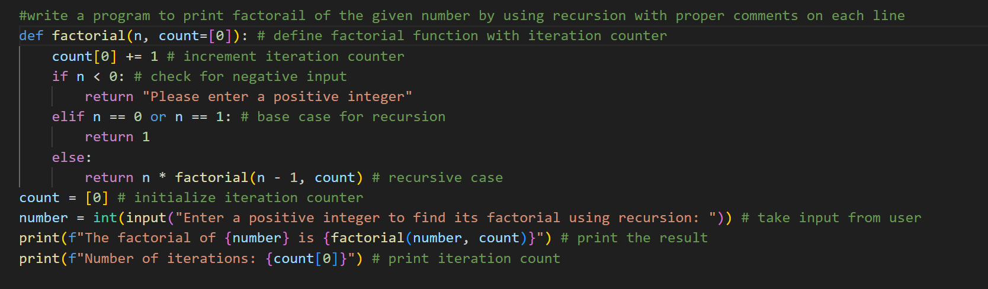

|  |
| --- |
| #write a program to print factorail of the given number by using recursion with proper comments on each line def factorial(n, count=[0]): # define factorial function with iteration counter  count[0] += 1 # increment iteration counter  if n < 0: # check for negative input  return "Please enter a positive integer"  elif n == 0 or n == 1: # base case for recursion  return 1  else:  return n * factorial(n - 1, count) # recursive case count = [0] # initialize iteration counter number = int(input("Enter a positive integer to find its factorial using recursion: ")) # take input from user print(f"The factorial of {number} is {factorial(number, count)}") # print the result print(f"Number of iterations: {count[0]}") # print iteration count |

**output:**

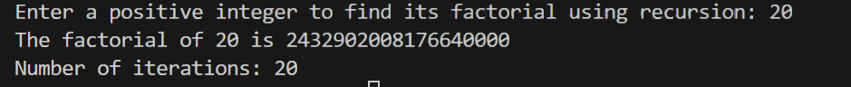



Comparison: Iterative vs Recursive Approach

|  |  |  |
| --- | --- | --- |
| **Criteria** | **Iterative Approach** | **Recursive Approach** |
| **Readability** | Easy to understand for beginners, logic is straightforward. | Code is shorter and elegant but may be confusing for beginners. |
| **Stack Usage** | Does not use call stack, memory usage is minimal. | Uses call stack for every function call, increases memory usage. |
| **Performance Implications** | Faster and more efficient for large inputs. | Slower due to repeated function calls and stack overhead. |
| **When Recursion Is Not Recommended** | Not applicable (safe for large inputs). | Not recommended for large inputs due to stack overflow risk and recursion limits. |